**Домашне завдання №16**

## **Основи тестування мобільних додатків**

**Перший рівень**

| ID number | #6 |
| --- | --- |
| Name | Main page - displaying a picture |
| Reporter | Kateryna L |
| Submit Date | 16/03/2023 |
| Summary | Picture is cropped in the section “Останні новини” at the body at the Main page |
| URL | https://kmlvm.com.ua/ |
| Screenshot |  |
| Platform | Samsung m20 |
| Operating System | Android 10 |
| Browser | Chrome 110.0.5481.154 |
| Severity | Major |
| Assigned to | / |
| Priority | High |

**Description**

Image is cropped in the section “Останні новини” at the body at the Main page

**Steps to reproduce**

> open https://kmlvm.com.ua/

> scroll down to section “Останні новини”

> look at the display of image

**Expected result**

The image is displayed in its entirety

**Actual result**

The image is cropped

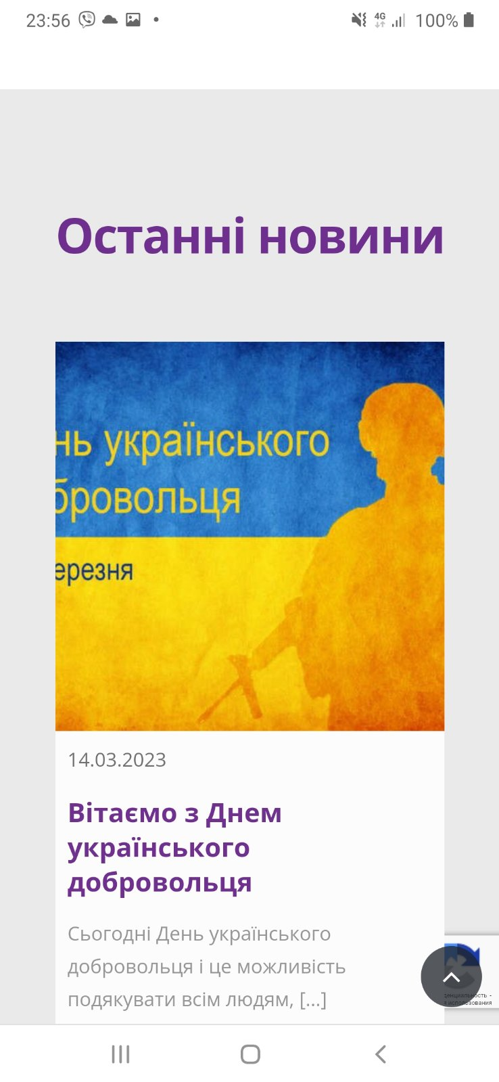

| ID number | #7 |
| --- | --- |
| Name | Error message about loading the page |
| Reporter | Kateryna L |
| Submit Date | 16/03/2023 |
| Summary | Front is too big in Error message about loading the page |
| URL | https://kmlvm.com.ua/ |
| Screenshot |  |
| Platform | Samsung m20 |
| Operating System | Android 10 |
| Browser | Chrome 110.0.5481.154 |
| Severity | Major |
| Assigned to | / |
| Priority | Medium |

**Description**

Front is too big at Error message about loading the page. The text about error perceived incorrectly

**Steps to reproduce**

>open https://kmlvm.com.ua/

> click at the Main Menu

> select “Штатний розпис на 2022 рік”

> look at the font of error message

**Expected result**

Correct message about error apaired

**Actual result**

Incorrect message about an error appeared. Font is too big.

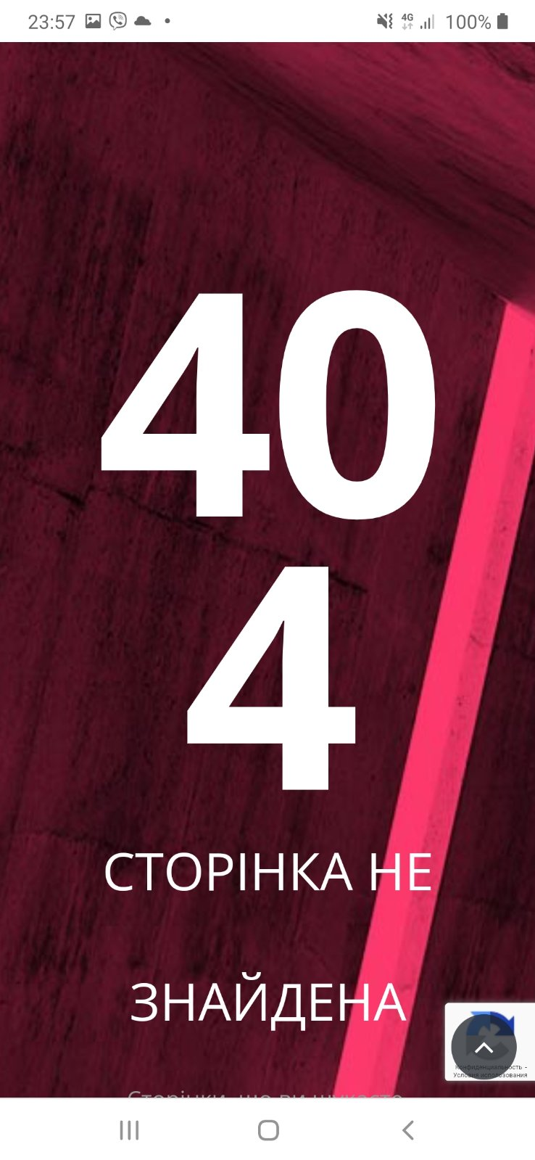

| ID number | #8 |
| --- | --- |
| Name | The text goes beyond the table |
| Reporter | Kateryna L |
| Submit Date | 16/03/2023 |
| Summary | The text goes beyond the table |
| URL | https://kmlvm.com.ua/ |
| Screenshot |  |
| Platform | Samsung m20 |
| Operating System | Android 10 |
| Browser | Chrome 110.0.5481.154 |
| Severity | Major |
| Assigned to | / |
| Priority | Medium |

**Description**

Front is too big for a table cell . The text does not fit into the table frame

**Steps to reproduce**

>open https://kmlvm.com.ua/

> click at the Main Menu

> select “Вакансії”

> look at the table

**Expected result**

Сorrect table display

**Actual result**

Incorrect table display. The text does not fit into the table frame

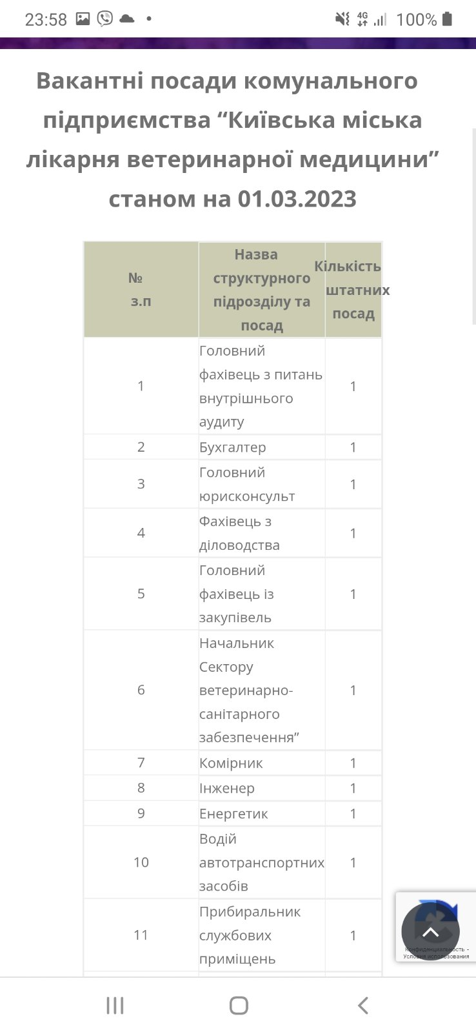

| ID number | #9 |
| --- | --- |
| Name | Text displaying |
| Reporter | Kateryna L |
| Submit Date | 16/03/2023 |
| Summary | The text is not displayed completely |
| URL | https://kmlvm.com.ua/ |
| Screenshot |  |
| Platform | Samsung m20 |
| Operating System | Android 10 |
| Browser | Chrome 110.0.5481.154 |
| Severity | Major |
| Assigned to | / |
| Priority | High |

**Description**

The text is not displayed completely. Incorrect indentation from the edge

**Steps to reproduce**

>open https://kmlvm.com.ua/

> click at the Main Menu

> select “Шукають домівку”

> look at the text under photo

**Expected result**

Text displays completely

**Actual result**

The text is not displayed completely. Incorrect indentation from the edge

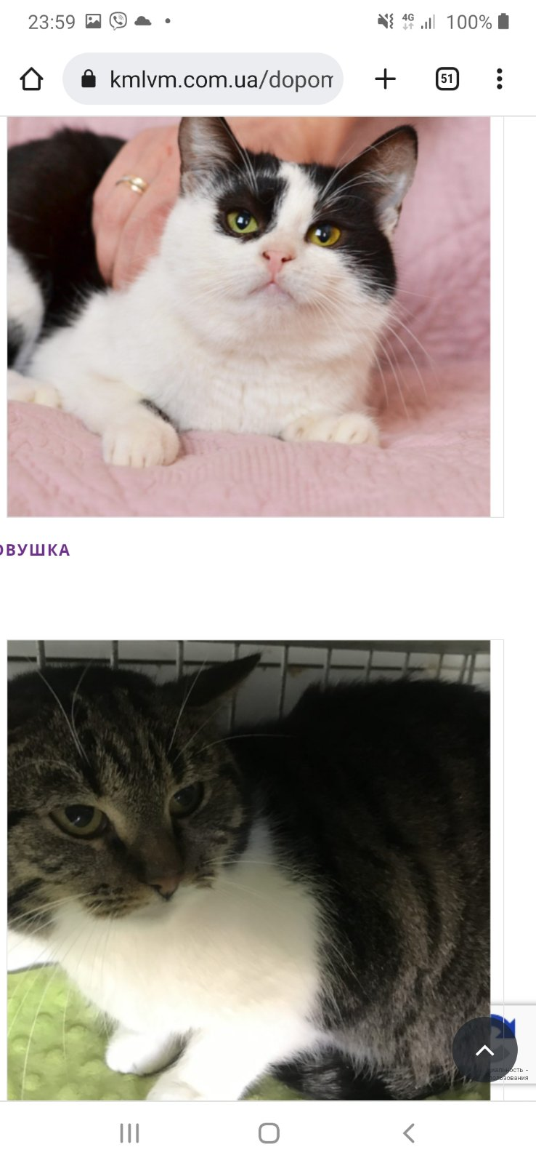

| ID number | #10 |
| --- | --- |
| Name | Text formatting |
| Reporter | Kateryna L |
| Submit Date | 16/03/2023 |
| Summary | The frame does not suit to the text |
| URL | https://kmlvm.com.ua/ |
| Screenshot |  |
| Platform | Samsung m20 |
| Operating System | Android 10 |
| Browser | Chrome 110.0.5481.154 |
| Severity | Major |
| Assigned to | / |
| Priority | Medium |

**Description**

The frame does not suit to the text

**Steps to reproduce**

>open https://kmlvm.com.ua/

> click at the Main Menu

> select “Ветеринарна допомога”

> scroll down to section “Структурні підрозділи”

> look at the text formatting

**Expected result**

The frame suits to the text

**Actual result**

The frame does not suit to the text

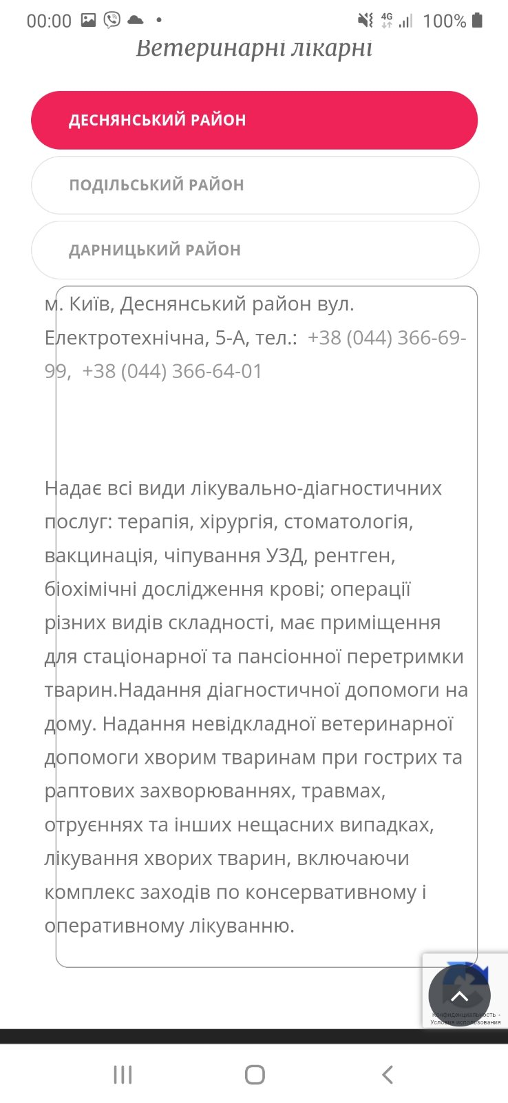

**Другі рівень**

| ID number | #11 |
| --- | --- |
| Name | [buttons] Incorrect language |
| Reporter | Kateryna L |
| Submit Date | 16/03/2023 |
| Summary | Label on buttons and text are in different languages |
| URL | https://zpolis.com.ua/ |
| Screenshot |  |
| Platform | Nexus 6P |
| Operating System | Android Oreo 8.1 |
| Browser | Chrome |
| Severity | Major |
| Assigned to | / |
| Priority | High |

**Description**

Label on buttons and text are in different languages

**Steps to reproduce**

>open https://zpolis.com.ua/

> click at the Галерея

> select album

> look at the button “Вернуться к альбомам”

**Expected result**

Label on button in Ukrainian language

**Actual result**

Label on button in Russian language

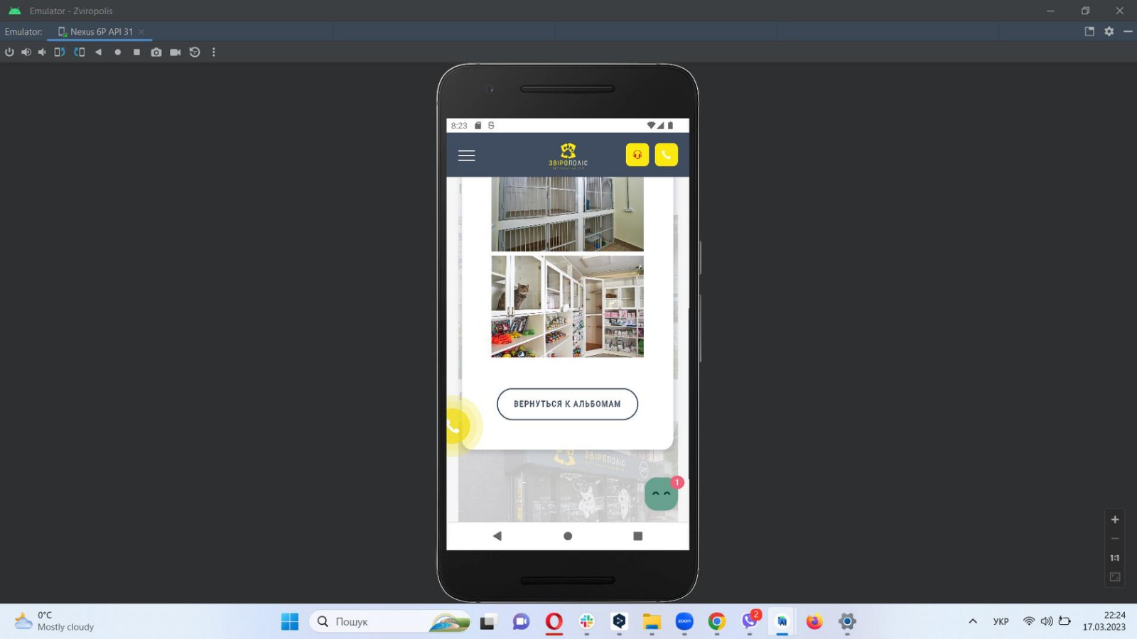

| ID number | #12 |
| --- | --- |
| Name | [text] Incorrect language |
| Reporter | Kateryna L |
| Submit Date | 16/03/2023 |
| Summary | Label on buttons and text are in different languages |
| URL | https://zpolis.com.ua/ |
| Screenshot |  |
| Platform | Nexus 6P |
| Operating System | Android Oreo 8.1 |
| Browser | Chrome |
| Severity | Major |
| Assigned to | / |
| Priority | High |

**Description**

Label on buttons and text are in different languages

**Steps to reproduce**

>open https://zpolis.com.ua/

> click at the Питання та відповіді

> click at the button “Читати далі” near Как проходит прием доктора

> look at the text

**Expected result**

Text in Ukrainian language

**Actual result**

Text in Russian language

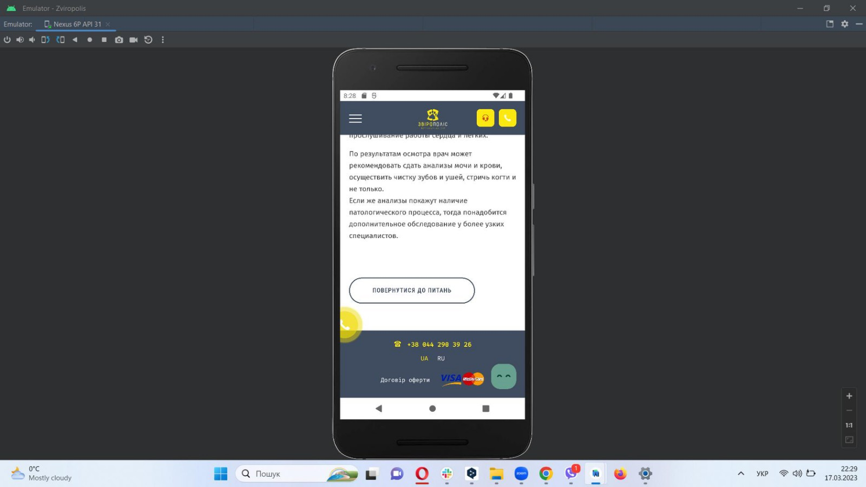

| ID number | #13 |
| --- | --- |
| Name | Text displaying |
| Reporter | Kateryna L |
| Submit Date | 16/03/2023 |
| Summary | Text of the dropdown list is not fully displayed |
| URL | https://zpolis.com.ua/ |
| Screenshot |  |
| Platform | Nexus 6P |
| Operating System | Android Oreo 8.1 |
| Browser | Chrome |
| Severity | Major |
| Assigned to | / |
| Priority | Medium |

**Description**

Text of the dropdown list is not fully displayed

**Steps to reproduce**

>open https://zpolis.com.ua/

> click at the Послуги

> look at the text in dropdown lists

**Expected result**

Text displays fully

**Actual result**

Text does not display fully

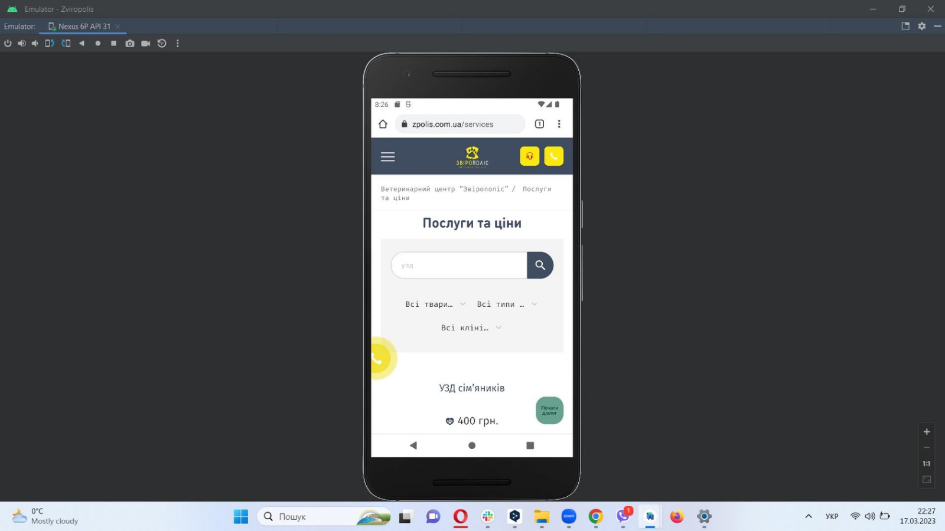

**Третій рівень**

**Checklist for testing mobile application Дія**

| **Mobile application Дія** | **Android** | **iOS** | **Windows phone** |
| --- | --- | --- | --- |
| **Usability testing** |  |  |  |
| 1. Click Документи |  |  |  |
| 2. Click Послуги |  |  |  |
| 3. Click Повідомлення |  |  |  |
| 4. Click Меню |  |  |  |
| 5. Click QR |  |  |  |
| **Functional testing** |  |  |  |
| 1. Test Search at the Послуги |  |  |  |
| 1. Test Downloading of Covid- certificat at the Covid сертифікати |  |  |  |
| 1. Test Entering the phone number at the form Дані для замовлення at Обмін лампочок |  |  |  |
| 1. Test Selection of the post office at the form Дані для замовлення at Обмін лампочок |  |  |  |
| 1. Test Filter at the Form of region selection of the post office at the form Дані для замовлення at Обмін лампочок |  |  |  |
| **Security testing** |  |  |  |
| 1. Ensure the data of users of the application (logins, passwords, bank card numbers) are protected from network attacks of automated systems and can not be found by selection |  |  |  |
| 1. Verify the application security system requires a strong password and does not allow the attacker to seize the passwords of other users |  |  |  |
| 1. Test Protection of the system from malicious implementations when the program is running |  |  |  |
| 1. Test Protection of the application against attacks of the SQL injection type |  |  |  |
| 1. Test Protection of the application and the network from DoS Attacks |  |  |  |
| **Performance testing** |  |  |  |
| 1. Verify the response time of the application meets the requirements |  |  |  |
| 1. Check the application stability under conditions of a hard user load. |  |  |  |
| 1. Ensure the performance of the application if it works under conditions of a non-permanent connection to the Internet. |  |  |  |
| 1. Make sure the existing client-server configuration provides optimal performance |  |  |  |
| 1. Evaluate the ability of the app to cope with planned load volumes |  |  |  |